The Snowman and The Snowdog Winter Kindness
Calendar

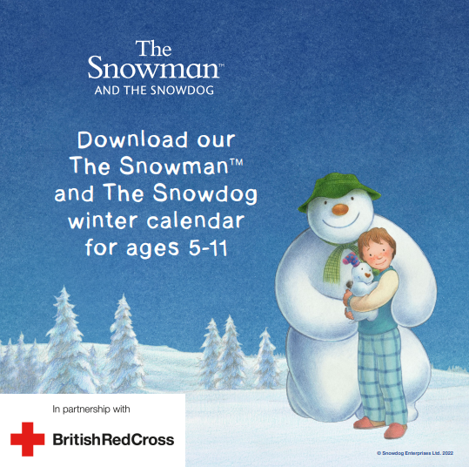

For the past few years, the British Red Cross have partnered with Snowdog Enterprises Ltd offering a free downloadable activity pack for anyone looking for things to do with the children over Christmas. Our callers can now download the British Red Cross’s The Snowman and Snowdog kindness calendar for free.

The calendars are aimed at children, aged 5-11. The amazing thing about this scheme, is that the children can learn about the importance of creating connections and valuing friendship with others by taking part in the kindness calendar and completing the tasks featuring the Snowman and The Snowdog (in partnership with Snowdog Enterprises Ltd).
Download link can be found here: The Snowman and Snowdog kindness calendar | British Red Cross

What steps do I need to take?
NB For callers who have children across either or both of the two age brackets (5-7) (7-11), would greatly benefit from this resource, have access to the internet and a printer.

- If not already disclosed, establish if the caller has any children between the ages of 5-11
- Explain that we have a free scheme called kindness calendar (as mentioned in the introduction above) and ask if this sounds like something they would be interested in?
-If yes, direct them to the download from BRC website www.redcross.org.uk>search bar>snowman> ‘The Snowman and The Snow Dog Kindness Calendar’
- Use keyword ‘SNOW’ at the top of your case notes and include that you signposted to the web page

Screenshot below of how caller can find the page –

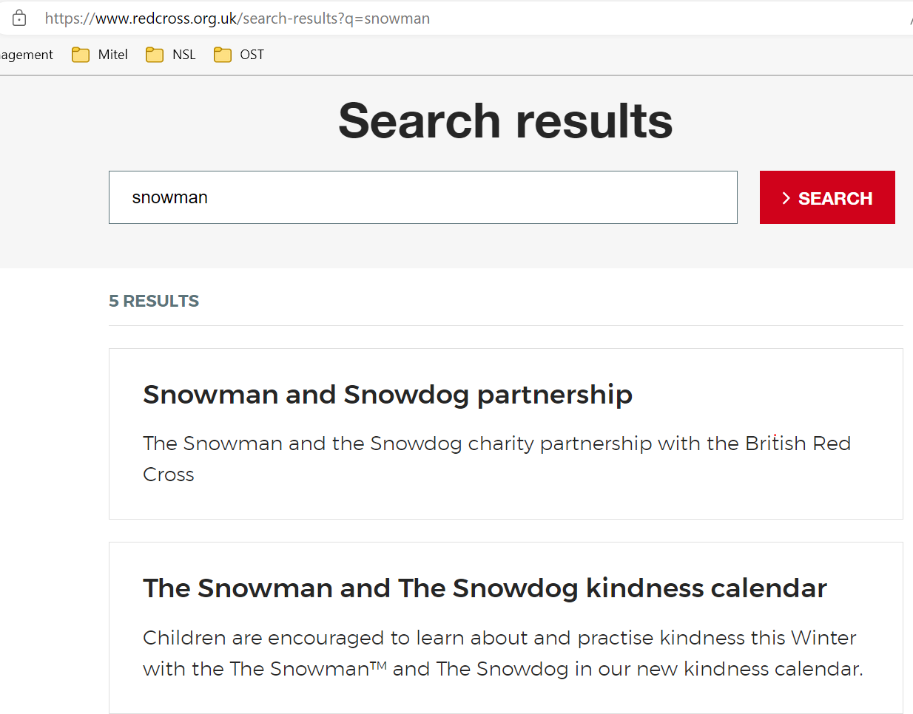
Advise caller to select this option to take them to the page where they can download the calendar

This is the page the caller will see when the click on the option in the image above

They will need to select the ‘download’ icon as shown here to download and print the calendars

