Mitel Ignite and Customer Survey Process

**Version control:**

|  |  |  |  |
| --- | --- | --- | --- |
| **Version** | **Date** | **Change(s)** | **By** |
| 1 | 19/04/2024 | Initial release | LJ |
|  |  |  |  |
|  |  |  |  |
|  |  |  |  |
|  |  |  |  |

Introduction

The customer feedback survey is being enhanced so that each survey can be assigned to the correct Operator. This will change the process slightly as detailed below. We will now transfer the service user to the survey via Mitel instead of hanging up the call.

How to Set Up Your Profile on Adept

This step will only need to be completed once when you initially set up your profile on the [Davies Technology - Adept (service tick.com)](https://console.servicetick.com/VOC/Auth/Login?ReturnUrl=%2FVOC%2FAdeptPortal) system. Once you click on this link you will be taken to a sign on screen as below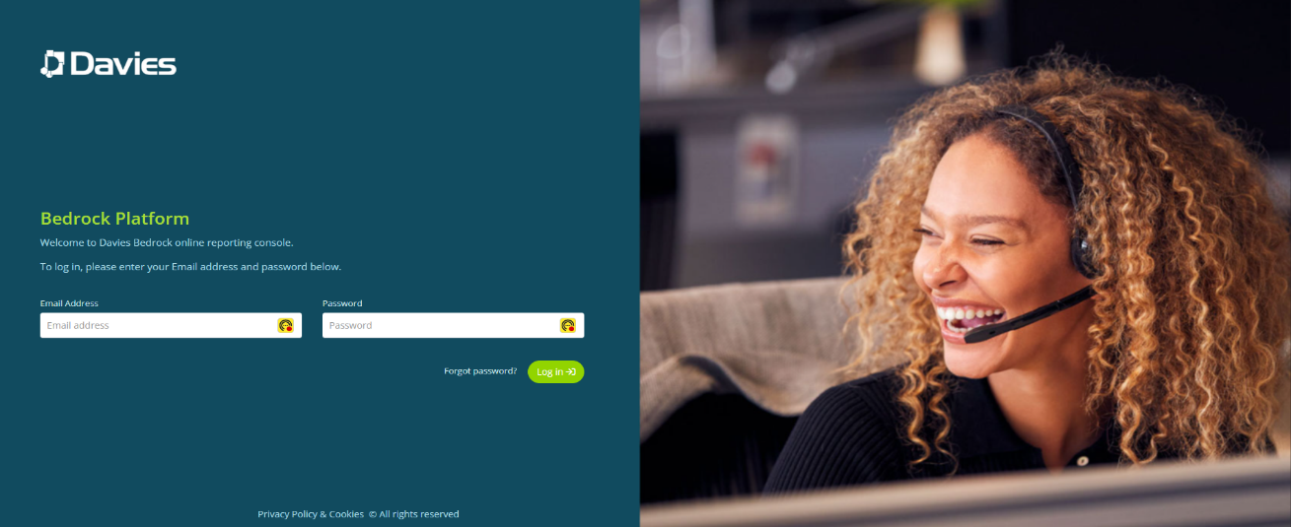

Click on **Forgot password** and this will take you to the screen below

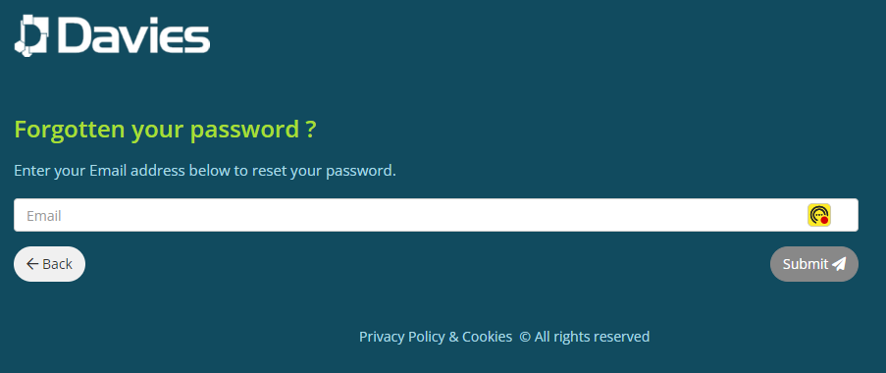

Type in your British Red Cross email address and press submit.

You will then be sent an email to your British Redcross Mailbox from Davies Technology with instructions on how to reset your password. You have up to 1 hour after your original request to go into the email and follow the instructions to reset your password. In this first instance it will say r*eset my password* which will let you set your initial password for this system. Passwords must be at least 12 characters long, have no spaces and contain at least the following:

* One lowercase character
* One Uppercase character
* One number
* One special character

This should automatically log you into the Davies Technology system, but if it does not, please go back to the initial sign in screen and put in your British Red Cross email address and the password you have just created.

You will then be taken to your home screen. This may say that a dashboard has not been set up for you but please ignore this and look at the icons down the left-hand side of the screen, you will see that the 3rd one down says **Adept**, this is what we will use going forward.

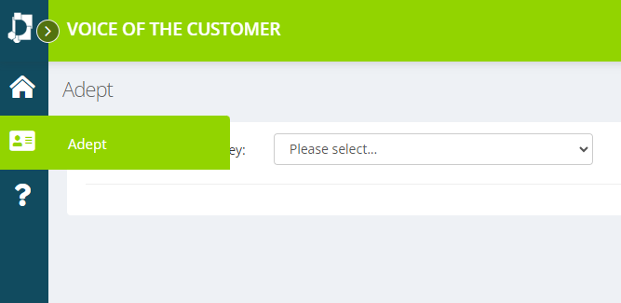

How to Register the Call on Adept

Please make sure that you are signed into the [Davies Technology - Adept (service tick.com)](https://console.servicetick.com/VOC/Auth/Login?ReturnUrl=%2FVOC%2FAdeptPortal) system. **NB** Suggest opening this at the beginning of each shift, so that it is to hand for each call, it should stay open all day and not time you out.

Once signed in click on the **Adept** tab on the left-hand side of the screen (as above) and choose **Customer Satisfaction Survey** from the drop-down box. This will open the Agent Data Entry section.

You ***only*** need to complete the sections **Agent PIN** (this is your 4-digit Agent number for Mitel), and the **Reason for call** (choose from one of the drop-down categories).

**NB** after the first time you have logged into the system it should automatically save your Agent PIN for any future calls.

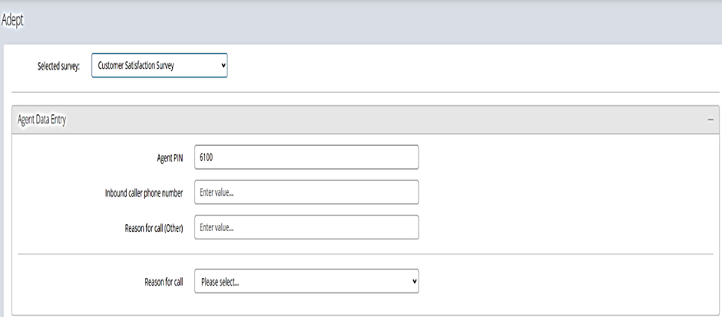



Next click on the + sign to open the next section **Survey Options.** The radio button for **Survey Now** should automatically be marked but if it is not, please click on this option

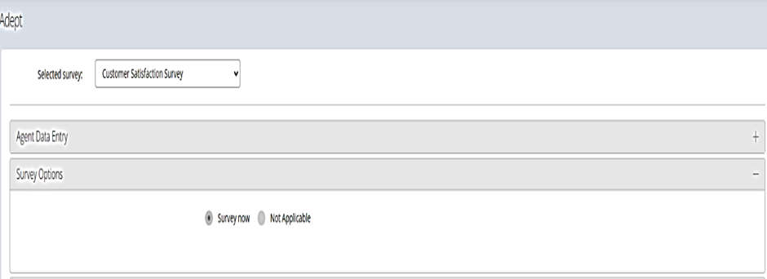



Next click on the + sign to open the next section **Survey Actions.**  When you are ready to transfer the service user to the survey Click on **Update PIN.**

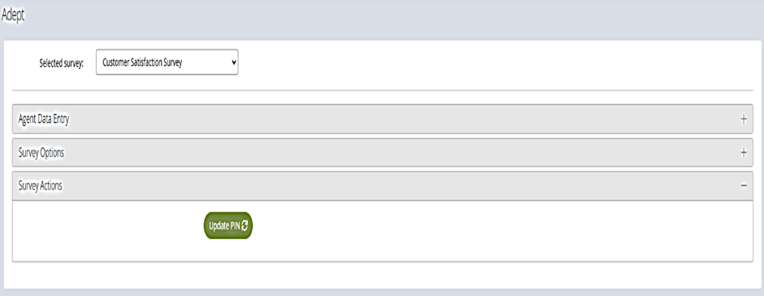



This will then refresh the section and give you a telephone number (Tel **02038352463**) to transfer the service user to (this can also be found on Mitel by searching for “**survey number**”). This section will also show your Agent number, as in the example below.

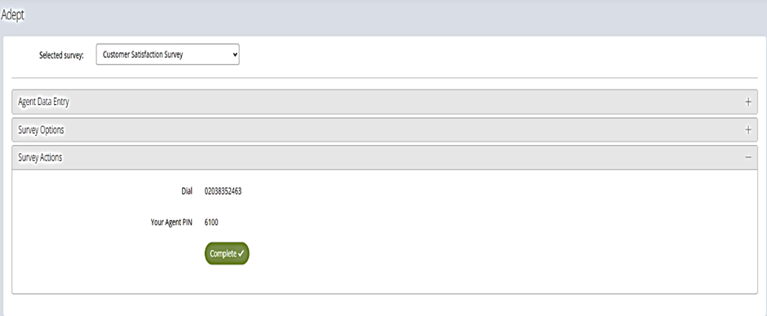



How to Transfer a Service User to the Survey using Mitel

You will need to transfer the call to the survey, by clicking on the **Transfer button** at the top right hand side of the Mitel Screen (please make sure you have the call details open on Mitel to access this).

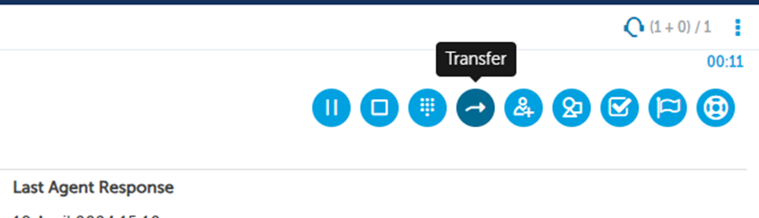

Next either type/paste the number from Adept (as above) or search for “**survey number**” in Mitel

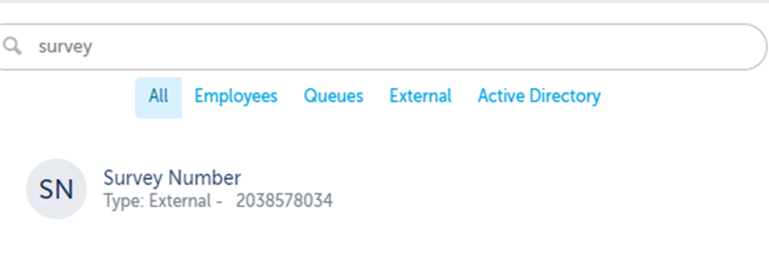

You will now make a conference call by clicking on the **Consultation Call** button.

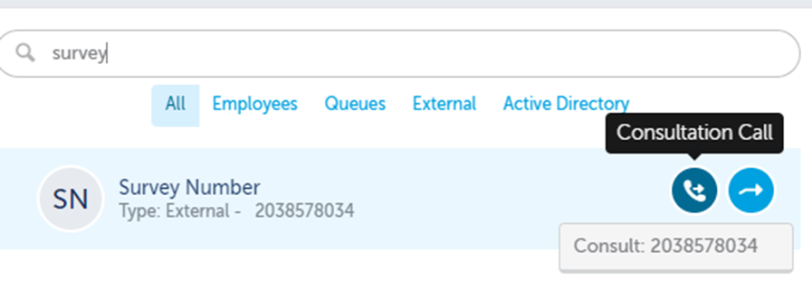

As soon as you click on consultation call you will hear the automated system/voice asking you to enter the pin, type in your **Agent number** using the **Dial Pad** on Mitel.

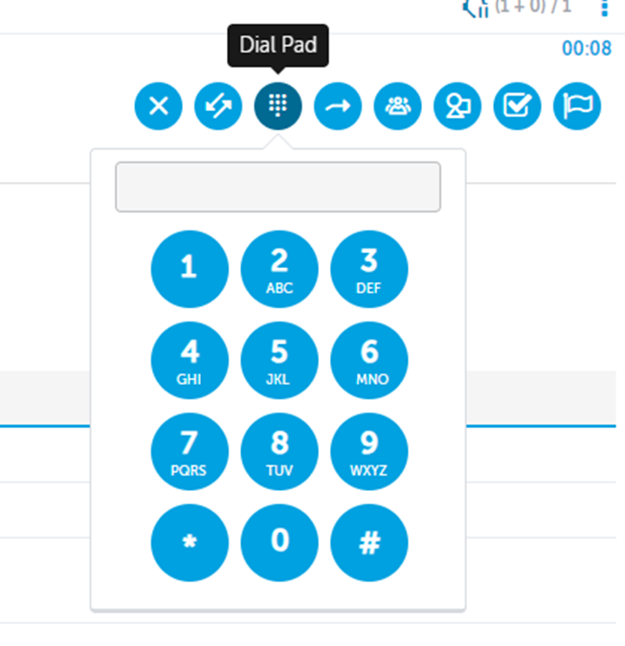

You will then transfer the caller to the survey pressing the **Complete Transfer** button next to the Dial Pad. This will disconnect you from the call and the Service User will be put through to the survey.

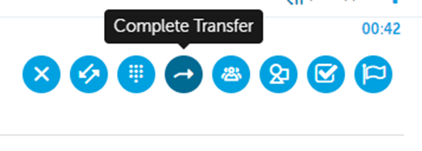

**NB - Pease note you only have a few seconds to type in your agent number and press the transfer button so the Service User can hear the full survey.**

To finish off the prosses please press **Complete** **on Adept** and write up your case notes as normal on Dynamics, so you are ready for your next call.



|  |  |  |  |  |  |  |  |  |
| --- | --- | --- | --- | --- | --- | --- | --- | --- |
| **Names** | **CL** | **HN** | **NJ** | **MB** | **PB** | **LJ** | **DR** | **EG** |
| **Read & Understood** |  |  |  |  |  |  |  |  |